Automation App Errors

1)Technical Error

1)Unknown Error in Login Response

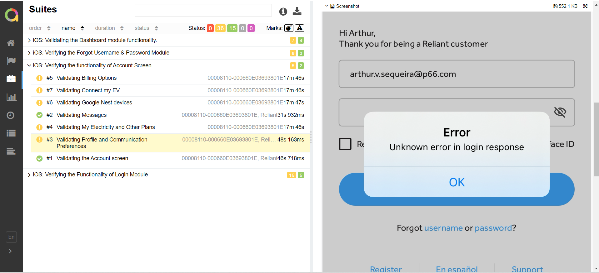

2)Unable to process your request

